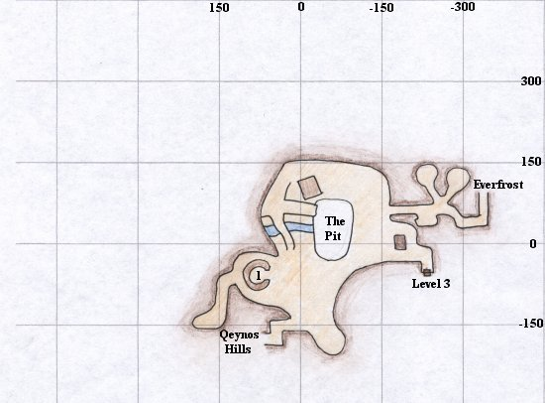

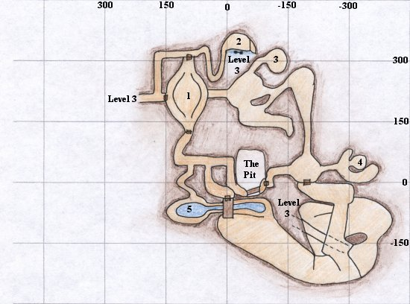

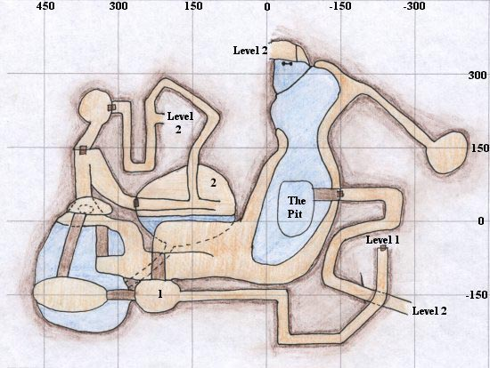

Winds of Karana

[**Classic Era**](https://wiki.project1999.com/Category:Classic_Era)([added 1999-2000](https://wiki.project1999.com/EverQuest_Timeline))

|  |  |
| --- | --- |
| **Start Zone:** | [Northern Karana](https://wiki.project1999.com/Northern_Karana) |
| **Quest Giver:** | [Vhalen Nostrolo](https://wiki.project1999.com/Vhalen_Nostrolo) |
| **Minimum Level:** | 20 |
| **Classes:** | All |
| **Related Zones:** | [Southern Karana](https://wiki.project1999.com/Southern_Karana) |
| **Related NPCs:** | [Cordelia Minster](https://wiki.project1999.com/Cordelia_Minster), [a hermit](https://wiki.project1999.com/A_hermit) |

Reward

* [Song: Jaxan's Jig o' Vigor](https://wiki.project1999.com/Jaxan%27s_Jig_o%27_Vigor)

Walkthrough

This quest starts with [Vhalen Nostrolo](https://wiki.project1999.com/Vhalen_Nostrolo" \o "Vhalen Nostrolo). Completed by an Agnostic Dark Elf Wizard with apprehensive faction.

You say, 'Hail, Vhalen'

Nice to meet you. Do not the plains of Karana about with life? This land is truly blessed by the gods. Would you like to hear a tune or will you pass up the opportunity?

You say, 'I would like to hear a tune.'

Inside this heart, I am trapped with the sight of beautiful colors, all memories of your love. They attack me with full might. You left me here in this garden of grey Never to see the true colors of the happiness of day Here in my hear I sit and I cry. You have left me alone and my colors have all died.... What do you think? Is it a happy tune or a sad tune?

You say, 'It is a sad tune.'

It takes a broken heart to truly appreciate that tune. I'm glad you enjoyed it. My dear Metala left me one year ago. The wound was healed, but the scar remains. I am presently trying to complete a new composition. Maybe that will turn me around.

You say, 'What new composition?'

I have come here to create my greatest composition. I call it 'The Winds of Karana'. Alas, the song sheets have been taken from me. While I, ahem, attended to some personal business, a hermit came and stole two song sheets from my pack. It would be grand if, in your journeys, you were to come upon this hermit of the plains and return my song sheets to me. I would pay dearly. Now, I must get back to my thoughts. Please excuse me.

Now, head southeast till you see a cottage. It has a hexagonal wall of stone surrounding it, so it's not hard to find. Inside the walls is [**a hermit**](https://wiki.project1999.com/A_hermit). A very unfriendly sort. The door to the hermits house is either locked, or broken and won't open. So it's hard to get to him.

The easiest way to get him out is to stand behind the hut and say "I'm here to kill you." You can also try to target him and attack him. After he is dead, his body will contain the [Cracked Flute](https://wiki.project1999.com/Cracked_Flute), [Winds of Karana sheet 1](https://wiki.project1999.com/Winds_of_Karana_sheet_1) or just one or the other.

Kill the hermit until you loot a flute, and a sheet music page.

The second piece is in the hands of [Cordelia Minster](https://wiki.project1999.com/Cordelia_Minster).

You say, 'Hail, Cordelia'

I can not find my flute, my favorite possession. Is there anyone who can [help] me?

You say, 'How can I help?'

My flute is missing, I think that old dirty hermit took off with it. He is always taking off with my things.

When you hand her the flute from the hermit...

Why thank you, kind adventurer! Here is a little something to keep food in your belly. Now back to practice. La la la..

**You gain experience!!**

You receive 1 silver

You receive [Winds of Karana sheet 1](https://wiki.project1999.com/Winds_of_Karana_sheet_1).

Now that you have both pages of sheet music, go back to Vhalen and give them both to him.

Thank you, my friend. I have just completed the composition. It is a work of art. Here. Have a copy. I hope you have the musical talent required to play it. If not.. Practice, practice, practice!

**You gain experience!!**